**For First Terminal Examination -2081**

Class-10

**Subject: Optional Mathematics Course Contents:**

1.Algebra: Function

2.Matrix: All

3.Coordinate Geometry: conditions for lines to be parallel and perpendicular

4.Trigonometry: Multiple angles Sub- multiple angles

5.Limit and continuity :all

6. Statistics :all

**For Second Terminal Examination -2081**

1.Algebra: Polynomials, Function

2.Coordinate Geometry: angle between two lines, pair of straight lines,

3.Trigonometry: transformation of trigonometric ratio, Conditional trigonometric identities

4.Vectors: all

5. Limit and continuity: all

6. Statistics: all

7. Matrix:all

**For Third Terminal Examination-2081 Course Contents**

* Algebra: sequence and series.
* Coordinate: conic section, circle
* linear programming problems.
* Quadratic equation and graphs.
* Limit and continuity.
* Trigonometry: * Solution of trigonometric equation
* Height and distance
* Transformation: All
* Revision all chapter

### EMBOCS NAWALPARASI

**Specification Grid for First Terminal Examination-2081**

|  |  |  |  |  |  |  |  |  |
| --- | --- | --- | --- | --- | --- | --- | --- | --- |
| S. N | Contents | Topic | K | U | A | H. A | Total number of Questions | Total mark |
| 1 | Algebra | * Function | 2 | 2 | 2 | 1 | 7 | 16 |
| 2 | Matrix | all | 1 | 1 | 1 |  | 3 | 6 |
| 3. | *Coordinate Geometry | conditions for lines to be parallel and perpendicular | 1 |  |  |  |  | 1 |
| 4 | Trigonometry | * Multiple angle * Sub – multiple angle | 2 | 2 | 3 | - | 7 | 15 |
| 5. | Statistics | All |  | 1 | 2 |  | 3 | 8 |
| 6. | Limit & continuity | All | 1 |  | 1 |  | 2 | 4 |
|  |  | Total mark | 7 | 6 | 9 | 1 | 22 | 50 |

### EMBOCS NAWALPARASI

**Specification Grid for Second Terminal Examination-2081**

|  |  |  |  |  |  |  |  |  |
| --- | --- | --- | --- | --- | --- | --- | --- | --- |
| S. N | Contents | Topic | K | U | A | H. A | Total number of Questions | Total mark |
| 1 | Algebra | * Function * Polynomials | 1 | 1 | 1 | 1 | 4 | 10 |
| 2 | Matrix | all | 1 | 1 | 1 |  | 3 | 6 |
| 3. | Coordinate Geometry | all | 1 | 1 | 1 | 1 | 4 | 10 |
| 4 | Trigonometry | * Multiple angle * Sub – multiple angle * Transformation of Trigonometric ratio * Conditional trigonometric identities | 2 | 2 | 1 |  | 6 | 9 |
| 5. | Vectors | * Scalar product * Vector Geometry | 1 | 1 |  |  | 2 | 3 |
| 6 | statistics | all |  | 1 | 2 |  | 3 | 8 |
| 7. | Limit & continuity | all | 1 |  | 1 |  | 2 | 4 |
| Total | | | 7 | 7 | 7 | 2 | 24 | 50 |
| Marks | | | 7 | 14 | 21 | 8 |  | 50 |

### EMBOCS NAWALPARASI

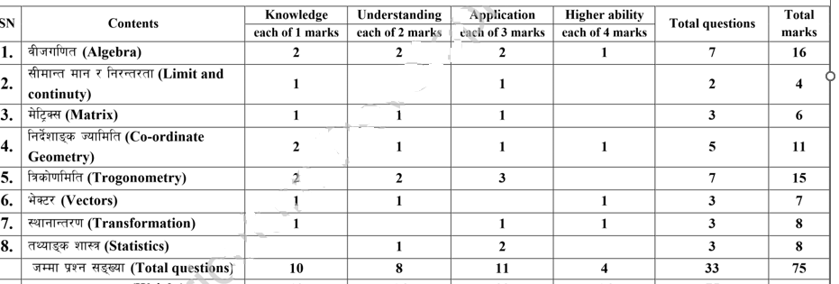 **Specification Grid for Third Terminal Examination-2081**

EMBOCS NAWALPARASI

Model Questions for First Terminal Examination -2081

**Sub: Opt : Math Time FM:50**

Class:10 **Group A 7x1=6**

1a. Define trigonometric function.

b) What is the maximum value of y=sinx.

2a) Write in sentence $\frac{lim}{x→a+}$ f(x).

b) Write the condition of two lines parallel.

3. a) Define singular matrix.

b) Express cos2A in term cosA.

4a) Write the formula to find sin3A.

Group B 6x2=12

5a.In the f= {(1, 2) ,(2, 3) , (3, 4) } and g= (2, a), (4, c) , (3, b) , then show the composite function gof in arrow diagram and find it in ordered pair form.

b) If F(x)=8x+7 then find the value of fof(x) and fof(-2)

6a)If matrix A= $[\begin{matrix}3 & 5 \\ 1 & 2\end{matrix}]$ Find the value of A-1.

b) prove that: $\frac{sin2A-sinA}{1-cosA+cos2A}=tanA$.

7a) IF sinA= $\frac{1}{2}$ (m+ $\frac{1}{m}$) then prove that: cos2A= - (m2+).

b) In a group data the quartile deviation and its Coefficient are 15 and $\frac{3}{7}$ respectively find first quartile.

Group C 9x3=27

8.IF f(x)=4x+5 , fog(x)=8x+17, find the value of g-1(7)

9. If f(x)=2x-5 and g(x)=3x+1 are two function then find f-1-(x) and g-1(x).

10.A real value function f:R $→R$ is Defined by f(x) = 2x + 3

i) find the value of f(x) at x= 4.9, 4.99, 4.999.

ii) find the value of f(5)

iii) Is this function continuous at x = 5.

11. Solve by cramers method: 8x+11=3y and 6y-15=-2x+11

12. prove that: Tan(45+A)=sec2A+tan2A

13. prove that :

14. prove that: 4cos320+4sin310

15. . Calculate the mean deviation from the median of the given data

|  |  |  |  |  |  |
| --- | --- | --- | --- | --- | --- |
| x | 0-10 | 10-20 | 20-30 | 30-40 | 40-50 |
| f | 2 | 3 | 5 | 4 | 6 |

16. Calculate the standard deviation from the given data.

|  |  |  |  |  |  |
| --- | --- | --- | --- | --- | --- |
| Class interval | 0-4 | 4-8 | 8-12 | 12-16 | 16-20 |
| Frequency | 10 | 8 | 12 | 6 | 4 |

Group D 1x4=4

17. Two functions are f(x)= $\frac{2x+5}{8}$ and g(x)=3x-4. If (fog)-1(x) is an identity function, find the value of x.

THE END

EMBOCS NAWALPARASI

Model Questions for Secondary Terminal Examination -2081

**Sub: Opt : Math Time FM:50**

Class:10 **Group A 7x1=6**

1a)Define identity function.

b) Write a condition to be a continuous for a function.

2a) If matrix A=( find A-1.

3a) If be the angle between the two straight lines whose equations are as

y=*m*1 *x* + *c*1 and *y* = *m*2 *x* + *c*2 , then find the value of tan $θ$.

b) The slopes of two straight lines L1 and L2 are M1 and M2 respectively. write the condition of parallelism of lines.

4a) Express sinA in term of tan $\frac{A}{2}$.

b) Write cosx+cosy into product form.

Group B 7x2=14

5a) If f(x)= $\frac{2x-3}{5}$, Find the value of f-1(

b) Find the obtuse angle between the lines 2x-y+3=0 and x-3y+4=0.

6a)Find the value of D1 and D2 from the given equation y=2x, x+2y=10 by cramers rule.

b) prove that: $\frac{sinθ+sin\frac{θ}{2}}{1+cosθ+cos{θ/}_{2}}$ = tan $\frac{θ}{2}$.

7a) Find the value of sin75 $°-sin15°.$

b )The position vectors of A and B are $\overset{→}{7i}+\overset{→}{2j}$ and $\overset{→}{3i}$- $\overset{→}{4j}$ respectively. If the point P is the midpoint of line AB, find the position vectors of point P.

8a) In a data , the first quartile and quartile deviation are 17.5 and 20 respectively. Find the third quartile and coefficient of quartile deviation.

Group C 7x3=21

9. If f(x)=2x-4, then prove that (fof-1)x is an identitity function.

10, If f(x)= $\left\{\begin{aligned}3x+5 x<3 \\ 6x-4 x≥3\end{aligned}\right.$

1. For x=2.9999, find the value of f(x)
2. For x=3.0001 find the value of f(x)
3. Is the function f(x) continuous at x=3.give reason

11. Prove that: 2cos4A+1= (2cosA-1) (2cosA+1) (2cos2A-1)

12. Solve the equation by matrix method. 2x-3y=7and 4y-3x= -1

13. Find the equation of a pair of line through (2,5) and perpendicular to the line 5x+2y=7

14. . Calculate the mean deviation from the mean of the given data

|  |  |  |  |  |  |
| --- | --- | --- | --- | --- | --- |
| x | 0-15 | 15-30 | 30-45 | 45-60 | 60-75 |
| f | 2 | 7 | 10 | 6 | 5 |

15. Calculate the standard deviation from the given data.

|  |  |  |  |  |  |
| --- | --- | --- | --- | --- | --- |
| Class interval | 0-4 | 4-8 | 8-12 | 12-16 | 16-20 |
| Frequency | 12 | 10 | 8 | 5 | 15 |

Group D 4x2=8

16.Find the equation of straight line passing through the point (3,2) and making angle 0f 45

17. Solve: y3-19y-30=0

***THE END****

EMBOCS NAWALPARASI

Model Questions for Third Terminal Examination -2081

**Sub: Opt : Math Time FM:75**

Class:10 **Group A 10x1=10**

